http://westerndigs.org/oldest-human-footprints-in-the-southwest-discovered-at-tucson-construction-site/

Oldest Human Footprints in the Southwest Discovered at Tucson Construction Site
POSTED BY BLAKE DE PASTINO ON JANUARY 21, 2016
TUCSON, ARIZONA — A day’s work in an Arizona corn field some 2,500 years ago has been frozen in time, thanks to the footprints of some ancient farmers, their children, and even their dogs, which have been found perfectly preserved at a construction site just north of Tucson.
The prints number in the dozens and depict the movements of several adults and at least one child, as they tended to their neatly arranged crops and the small irrigation ditches that watered them.
Discovered in November by archaeologists investigating a parcel of land near Interstate 10, the prints are likely the oldest human tracks yet found in the American Southwest.
What’s more, the footprints provide a glimpse into the daily life of people who practiced some of the earliest agriculture in the region, in intimate detail.
“One of the things in archaeology that we always wish for is a time machine — to go back in time and see what people really did, to look at a dirt pile and go, ‘So, that’s what they were doing,’” said Dan Arnit, the excavator who made the find.
“Well, I think I found a time machine. Because the only thing that’s missing here is the person standing in the steps.”
The barefoot tracks are distinct enough that the movements of specific individuals can be followed across the 15-meter-square field that’s been uncovered, Arnit said.
In one case, a set of deep, large prints shows that a heavy adult male trod diagonally across the field, stopped to do some work on an earthen berm, or perhaps to open a weir to let in water, and then took a different path across the field and over the ditch.
Another set of prints seems to have been made by an infant or toddler. And one print has a dog print inside it, likely made by a farmer being followed by his or her canine companion.
The tracks were preserved in such pristine condition because of a sudden flood from a nearby creek, archaeologists said.
The creek overran its banks soon after the prints were made, covering them in its uniquely mica-rich sandy sediment, forming a kind of mineralized cast.
Archaeologists discovered the prints under this layer while researching the site before a road is to be redirected through it.

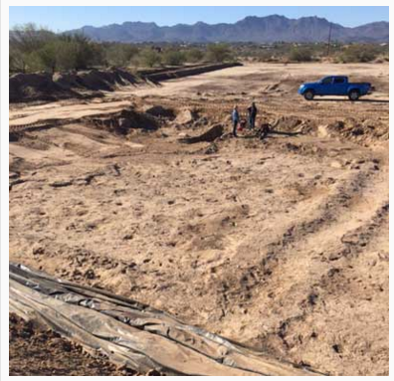

Archaeologists uncovered this 2,500-year-old farming field at a road-construction site. A small irrigation ditch is clearly visible on the right, with earthen berms below it. The larger holes are thought to be depressions where plants were placed; the many smaller pocks are footprints. (Copyright Western Digs. May not be used without permission.)

“We knew two years ago [when the project began] that there was a lot of archaeology that needed to be addressed,” said Jerome Hesse, project manager for SWCA Environmental Consultants, which is conducting the study.
Previous research done nearby had turned up traces of multiple residences from the Hohokam, or Ancestral Sonoran Desert culture, dating back 900 to 1,000 years, he said.
But at the site of the new roadbed, as the researchers dug deeper — and therefore further back in time — their test trenches turned up very little at first.
“The area out here, remarkably, didn’t have anything in the trenches,” Hesse said.
“So we scratched our heads and thought maybe this was an area that was being used for agriculture.
“We were lucky enough to come down on this area, where the preservation is remarkable.”
The fields appear to date to the Early Agricultural Period, a span between about 2500 BCE and 50 CE when some of the Southwest’s first farmers began cultivating crops, preceding the Hohokam by 500 years or more.
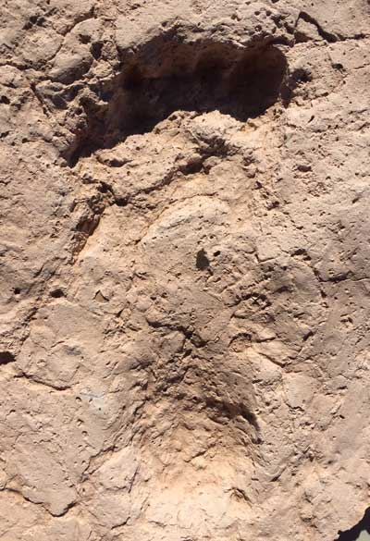This footprint is among the dozens found at the road-construction site, under a layer of mineral-rich sediment. Archaeologists estimate their age at 2,500 to 3,000 years, making them the oldest human prints yet found in the American Southwest. (Copyright Western Digs. May not be used without permission.)

“We don’t have a firm date, but during phase one [of the excavations], we ran a number of radiocarbon samples, and it’s at about that level … from 2,500 to 3,000 years old,” Hesse said.
The fields, the shallow ditches around them, and even the small depressions where archaic farmers placed individual plants of corn and other crops may stretch far and wide throughout the area, he added.
“Under the Hohokam sites, there are more of these,” Hesse said, “not necessarily the footprints, but the fields, the irrigation ditches, the little planting depressions.
“So we’ve excavated a number of these planting depressions and will run samples for pollen and phytoliths [microscopic plant remains] to get a sense of what was being grown.”
For now, the first order of business is to preserve at least some of the ancient prints, since the site will soon be paved.
“We’re doing everything we can to document the footprints, because they are smack-dab in the middle of the road,” said Dr. Suzanne Griset of SWCA, the project’s principal investigator.
The nonprofit Archaeology Southwest is conducting 3-D photo scans of the site to create a digital model, and some of the prints have been cast with synthetic molds, while others have been extracted completely to be sent to nearby museums.
For Arnit, the excavator and owner of the firm Innovative Excavating, finding the first footprint was an archaeological experience on the order of winning Powerball.
“I found what looked like a heel, and then I went up into this area. And it was like the lottery, and this is the last number I’m scratching off,” Arnit said.
“And when I saw that big toe, I tell you, I was jumping up and down.”

