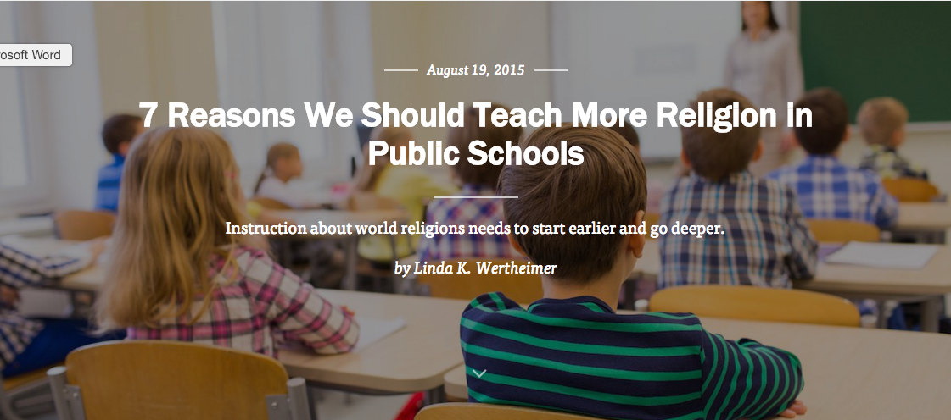
Teachers in the suburban town of Wellesley, Massachusetts spend half the school year teaching the world’s religions to sixth graders. These 11 and 12 year olds learn about major figures, holidays, geography, and beliefs central to Judaism, Christianity, Islam, and Hinduism. They take field trips to a mosque and Jewish temple. They debate the pros and cons of not having school on Muslim holidays.
High school students in Modesto, California take a world religions class in order to graduate — the only public high school with such a requirement. And at a Wichita, Kansas elementary school, students begin learning simple facts about three different world religions in first grade as per the Core Knowledge curriculum.
Many people wrongly view religion as a taboo subject, not to be discussed in America’s public schools. According to a 2010 survey by the Pew Research Center, a little more than half of those polled thought teachers were prohibited from offering a class comparing the world’s religions, while only 36 percent (correctly) thought it was legal to offer such courses.
Sure, most Americans know that a 1963 Supreme Court ruling prohibited public school teachers from leading a class in prayer. But they tend to miss the rest of that ruling, which emphasized that teachers have always been allowed to teach about religion academically.
For more than a decade, most states have required world religion to be taught as part of social studies and geography standards. Yet, the examples above are rare. Typically, schools teach about religion briefly in secondary social studies.
Here are seven reasons it’s time to start the instruction earlier — and make sure it goes deeper:

1. Teasing about religious differences starts as early as kindergarten.
Around the country, I heard numerous stories from children being bullied because of their faith. A young Sikh man recalled his first week in kindergarten and how his peers tore off his patka (the religious head covering he wore). A Muslim boy stood by his locker in fourth grade and a classmate said, “Hey, is there a bomb in your locker?”
Jewish children talked about middle school peers throwing pennies at them as a jab at the stereotype about Jews and money. Another student said high school peers asked her if her family belonged to a cult because they were Jehovah’s Witnesses.

2. Religion plays a role in history, literature, and current events.
It would be hard to teach Nathaniel Hawthorne’s The Scarlet Letter without talking about the Puritans or discuss Elie Wiesel’s Night without learning about Judaism and the Holocaust.
Religious conflict, between different religions or branches of the same faith, regularly plays a role in the news. How can anyone understand what’s happening in the world without basic knowledge of world religions?

3. The United States’ religious makeup is changing.
The Christian share of the population declined from nearly 80 to 71 percent between 2007 and 2014, and the percentage of people from other faiths and the unaffiliated rose, according to a Pew demographic study released this year. The percentage of Muslims, and Hindus are rising the most. Children should learn about the growing diversity of religion within their own country.

4. Americans are woefully ignorant about religion.
Teachers tell me that many students start middle or even high school not knowing that Catholics are Christians, too. On a grander scale, the 2010 Pew survey on U.S. Religious Knowledge shows that adults fared poorly on a quiz about the world’s religions. Most didn’t know that Friday evening was the start of the Jewish Sabbath or that the Dalai Lama was a Buddhist.
More than half of Americans know that the Koran is the holy book of Islam. But less than a third could answer this: What is the religion of most people in Indonesia? The answer: Muslim.

5. Schools need to better understand the difference between celebration and education.
Some schools cling to old traditions of celebrating Christmas by holding Christmas concerts with sacred music and taping Christmas decorations to the classroom door. In Modesto, the first teachers of the required world religions course went through training with the First Amendment Center, and many saw themselves as advocates and enforcers of the First Amendment in their schools.
One pair of educators ran into conflicts with their high school’s front office staff, who kept putting “Merry Christmas” on the outside marquee. The educators complained, and the school responded by posting a tiny “Happy Hanukkah” sign in the office and leaving “Merry Christmas” on the marquee. The educators showed the school administrator what his handbook said — that educators cannot give preference to one faith over another in a public setting.

6. Even young children can be taught about world religions in simple terms.
In Wichita and in Malden, Massachusetts, I saw first grade teachers educating 6 and 7 year olds about religion with songs, arts and crafts, read-alouds, and other activities. In one lesson, children learned symbols for each religion. Does it make a difference?
One teacher described how a child might recognize the Star of David in a nearby cemetery and understand that it’s there to remember a Jew. At the minimum, children realize the world has many religions.

7. Schools can learn best practices to make these teachings successful.
Middle and high school world history teachers often get instruction about religion as part of history courses in college. But for elementary teachers, it’s hit or miss depending on where they attend college. Teachers can get tips from guides on teaching about religion in the public schools by the First Amendment Center and the American Academy of Religion. Some universities and organizations offer continuing education programs and courses — and Wellesley, Modesto, and Core Knowledge schools also can serve as models.
* * *
Perhaps the biggest challenge for schools may be persuading communities why the lessons on religion matter so much given the pressure to help students master so many subjects already. Wellesley, which faced some opposition after taking students to a Boston mosque in 2010, sees openness as part of the solution.
Adam Blumer, Wellesley Middle School’s social studies department head, knew teaching about religion could lead to controversy even in a liberal town in a state considered among the most secular in the country. He created a two-page letter for teachers to send home to parents before the religions unit began.
In that letter, he addressed two questions: “Why teach about religion at all? Why teach about it in middle school?” He listed several reasons, including religion’s role in culture and its attempt to explain the unexplainable, as well as the school system’s goal to teach students respect for human differences. And why middle school? Because that’s often when children are wrestling with the kinds of questions religion addresses: “Who am I? How am I unique? How am I part of a larger community? How do good people act? What is bad? Why do seemingly unexplainable things happen?”
Why teach more about religion in public school? Because religion weaves itself into the fabric of life in America and the world, regardless of whether or not someone adheres to a particular faith.

http://www.faithstreet.com/onfaith/2015/08/19/7-reasons-we-should-teach-more-religion-in-public-schools/37665
Image courtesy of nataliesap.

